Free Monthly Parent Webinars from the School Nursing Team
We are pleased to offer a series of free monthly online webinars for parents and carers commencing October 26, providing practical advice and support on a range of children's health and wellbeing topics:
🌙 Sleep – Tips for establishing healthy sleep routines and managing common sleep difficulties.
🚻 Continence – Information and support to help children develop healthy bladder and bowel habits. * if a child has symptoms such as pain when using the toilet, blood in their urine or poo, repeated infections, unexplained weight loss, severe constipation please seek advice from your GP before joining the webinar.
🥗 Healthy Lifestyles – Advice on nutrition, physical activity, screen time, and building healthy habits for the whole family.
💙 Behaviour and Emotional Health – Understanding behaviour, supporting emotional wellbeing, and helping children build resilience.
All webinars are delivered online by members of the School Nursing Team and are free to attend. No referral is required. Parents and carers can book directly onto any webinar using the registration links available on our website.
To book a place, visit: https://lancschildandfamily.co.uk/
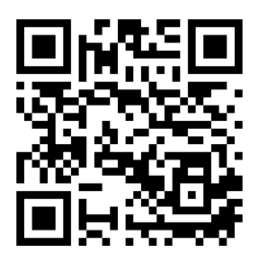
Or Scan the QR Code

