Grimsargh St Michael’s C of E Primary School

Religious Education Policy

Vision and Purpose
At Grimsargh St Michael’s Church of England Primary School, Religious Education is a core subject and lies at the heart of our curriculum and our life as a Church school.
RE makes a distinctive contribution to our vision:
Inspiring, Believing and Achieving in our Loving Christian Community.
“Let your light shine before others, that they may see your good deeds and glorify your Father in heaven.” (Matthew 5:16)
Our Christian vision is rooted in the belief that every child is uniquely created and infinitely valued by God. Through Religious Education, pupils are inspired to explore life’s big questions, believe in their own God-given potential and achieve academically, spiritually and personally.
As a Church of England Voluntary Aided School, Religious Education is taught in accordance with the Church of England Religious Education Statement of Entitlement (2026), Blackburn Diocese Questful RE 2026, the National Content Standard for Religious Education, the Blackburn Diocese Vision for Education and the Trust Deed of the School.

Mission Statement for Religious Education
At Grimsargh St Michael’s, Religious Education is a key vehicle through which our Christian vision is lived out. Through engagement with Christianity and a range of religious and non-religious worldviews, pupils are equipped to flourish and positively impact the world around them.

Intent
Religious Education lies at the heart of our curriculum and enables all pupils to become religiously literate young people. Through the Questful RE curriculum, pupils engage thoughtfully, respectfully and critically with Christianity as a living and diverse global faith, other principal world faiths and non-religious worldviews. Through enquiry, reflection and authentic encounters, pupils explore questions of meaning, purpose, identity and belonging, developing the knowledge, understanding and wisdom needed to flourish in a diverse and changing world.

Through RE, pupils develop curiosity, reflection, empathy and respect; gain a deep understanding of how faith and belief shape individuals, communities and society; explore and articulate their own developing worldview; and grow as courageous advocates who flourish spiritually, morally, socially, culturally and academically.

Religious Education at the Heart of the Curriculum
The Governors have adopted the Blackburn Diocese Board of Education syllabus: Questful RE 2026.
This syllabus reflects the Church of England Religious Education Statement of Entitlement, the National Content Standard for Religious Education, Blackburn Diocese expectations, SIAMS requirements and current Religion and Worldviews thinking.
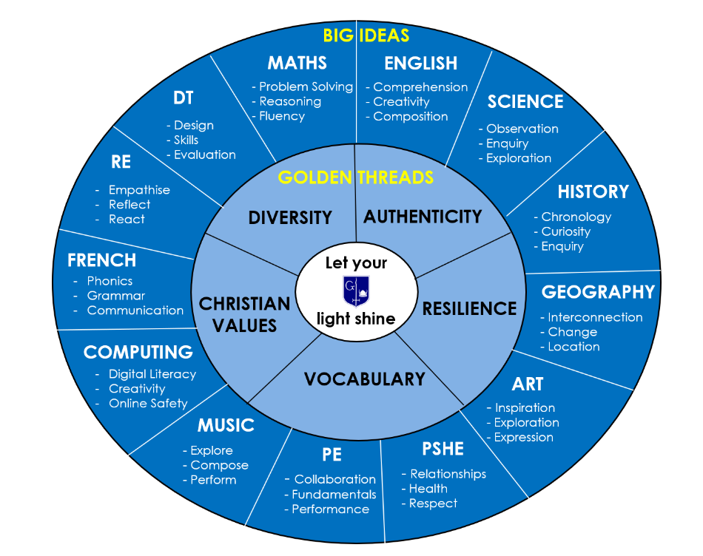
Religious Education occupies a distinctive place within the curriculum and contributes significantly to pupils' spiritual, moral, social, cultural and academic development.

Curriculum Design
The curriculum is underpinned by five Golden Threads: Authenticity, Vocabulary, Diversity, Resilience and Christian Values.
Religious Education develops understanding through three Big Ideas:

- Empathise: understanding beliefs, values and experiences of others.
- Reflect: exploring questions of meaning, purpose, truth and identity.
- React: evaluating ideas and engaging respectfully in informed dialogue.

The Questful RE Framework
Questful RE is structured through three interconnected forms of knowledge.
Knowing (Substantive Knowledge): beliefs, teachings, sacred texts, traditions, practices and sources of authority.
Thinking (Disciplinary Knowledge): Theology (Believing), Philosophy (Thinking) and Human and Social Sciences (Living).
Living (Personal Knowledge): reflecting on personal beliefs and experiences, developing a worldview and respecting the views of others.

Religion and Worldviews
Religious Education reflects contemporary Religion and Worldviews approaches. Pupils study Christianity and a range of religious and non-religious worldviews through theology, philosophy and the human and social sciences. Pupils explore both shared beliefs and diverse lived experiences within traditions, developing a nuanced understanding of religion and belief in the modern world.

Religious Education Entitlement
All pupils are entitled to engage critically and meaningfully with a multi-religious and multi-secular world; understand Christianity as a diverse global living faith; learn about a range of religious and non-religious worldviews; explore questions of meaning, purpose and identity; develop religious literacy; and articulate their own developing worldview.

Understanding Christianity
Pupils learn about God as Father, Son and Holy Spirit; the biblical narrative of Creation, Fall, Salvation and Hope; scripture, tradition and reason as sources of authority; Christian discipleship; and the Church locally, nationally and globally.
Pupils learn from the life and teachings of Jesus, Christian examples of love, forgiveness, reconciliation, justice and service, and faith in action within communities today.

Implementation
Teaching incorporates theology, philosophy, human and social sciences, Understanding Christianity, biblical literacy, authentic encounters, visits, visitors, enquiry, discussion, debate, reflection and progressive development of religious literacy.
Pupils regularly work as theologians, philosophers and human and social scientists.

Diversity and Worldviews
Teaching challenges stereotypes, promotes dignity and respect, explores authentic lived experiences, encourages informed dialogue and reflects diversity within and between religious and non-religious worldviews.

Pupils encounter diversity within Christianity, including Anglican, Catholic, Orthodox, Pentecostal and Global Majority expressions of faith, as well as diversity within other principal world faiths and non-religious worldviews. Through engaging with lived experiences and a range of perspectives, pupils develop religious literacy, challenge misconceptions, deepen their understanding of their own and others' worldviews, and grow in empathy, respect and wisdom, enabling them to flourish within a diverse society.

Religious Education, Vision and Human Flourishing
At Grimsargh St Michael’s, RE is a key vehicle through which our Christian vision is understood and lived out.
In line with the Church of England Vision for Education, RE contributes to the development of Wisdom, Hope, Community and Dignity alongside the Blackburn Diocese values of Love, Hope, Grace and Service.
RE supports pupils in recognising their God-given worth and uniqueness and prepares them to flourish in God’s world.

Curriculum Time
At least 5% of curriculum time is devoted to Religious Education. Christianity remains the principal religion studied and approximately two-thirds of curriculum time focuses upon Christianity.

Assessment
Assessment follows Questful RE 2026. Progress is assessed through Theology (Believing), Philosophy (Thinking) and Human and Social Sciences (Living).
Assessment focuses on religious literacy, substantive knowledge, disciplinary knowledge and application of learning. Assessment does not judge personal belief.

Religious Literacy Outcomes
By the end of primary education pupils should be able to give a thoughtful and informed account of Christianity as a living faith; demonstrate understanding of a range of worldviews; engage respectfully in meaningful dialogue; appreciate diversity within and between traditions; reflect critically upon questions of meaning and purpose; and articulate their own developing worldview.

Impact
Through RE, pupils become religiously literate learners, reflective thinkers, respectful and compassionate individuals, confident communicators, courageous advocates and young people equipped to flourish.
Impact is evaluated through pupil voice, book scrutiny, lesson visits, learning walks, assessment information and monitoring activities.
The impact of Religious Education is further evidenced through pupils' ability to make informed connections between beliefs, practices and lived experience, and through their growing understanding of Christianity as a diverse global living faith.

Leadership, Monitoring and Evaluation
The RE Subject Leader monitors curriculum coverage, planning, teaching, learning, assessment and standards. Governors receive regular reports, monitor provision, evaluate effectiveness and ensure statutory and diocesan requirements are met.

SEND and Inclusion
RE is fully inclusive. We create a positive learning environment, provide appropriate scaffolding, maintain high expectations and work closely with families and external agencies to support all learners.

Resources
Resources include Questful RE 2026, Understanding Christianity, sacred texts, artefacts, visitors, educational visits and digital resources.

Parental Right of Withdrawal
Parents have the legal right to withdraw their child from Religious Education. Requests will be discussed with the Headteacher and appropriate arrangements made.

Policy Review
This policy will be reviewed annually by the RE Subject Leader, Senior Leadership Team and Governing Body.
Signed: Helen Smith
Review Date: September 2027

