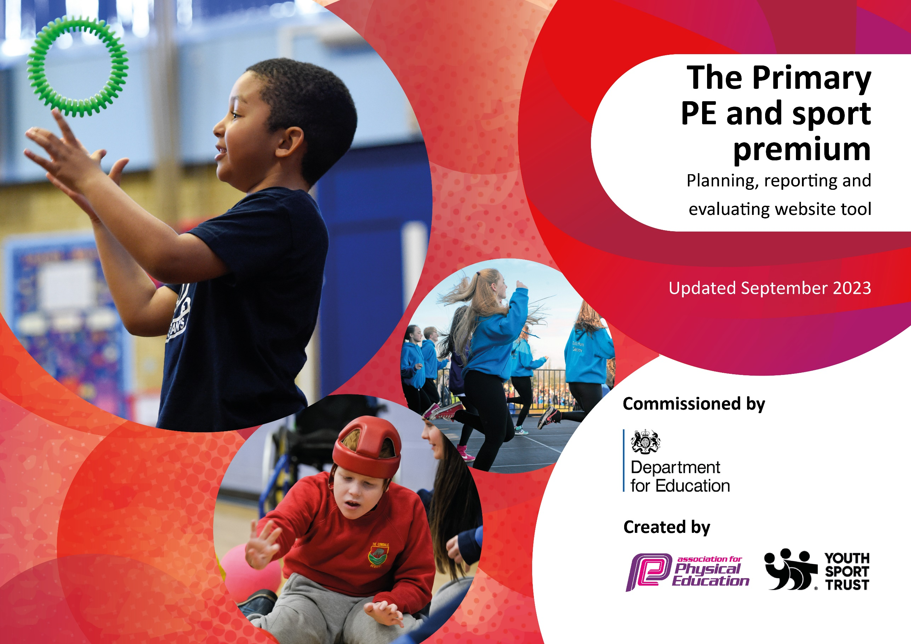

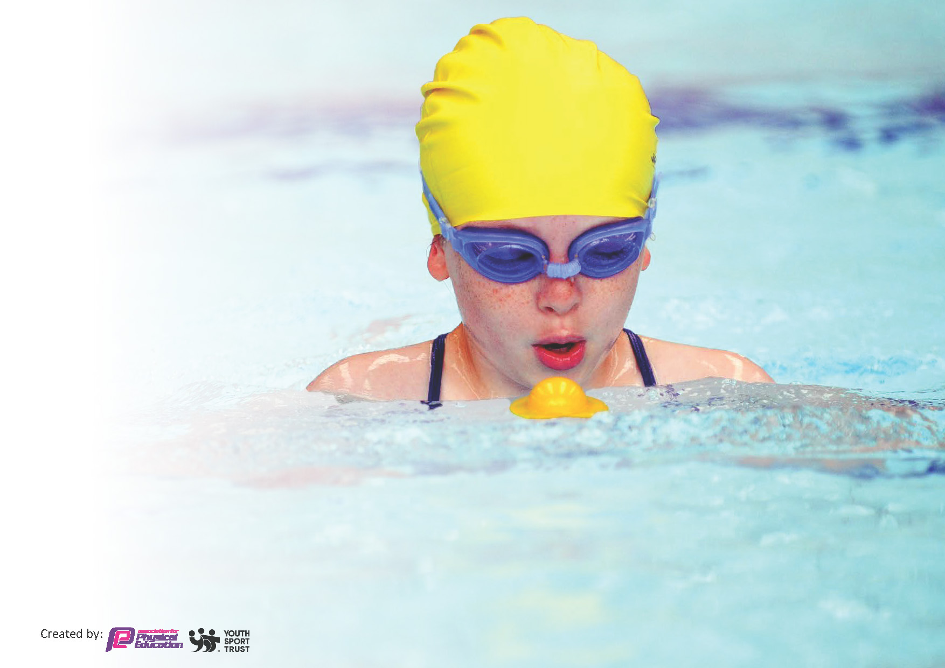
This template can be used for multiple purposes:
by:
- It enables schools to effectively plan their use of the Primary PE and sport premium
- It helps schools to meet the requirements (as set out in guidance) to publish information on their Primary PE and sport premium
- It will be an effective document to support Ofsted inspections enabling schools to evidence progress in Physical Education (PE) and evidence swimming attainment, which forms part of the PE National Curriculum. We would recommend schools consider
the Intent, Implementation and Impact of any spend, as examined within the Education Inspection Framework.

It is important that your grant is used effectively and based on school need.

Schools must use the funding to make additional and sustainable
improvements to the quality of the PE, School Sport and Physical Activity (PESSPA)
they offer. This means that you should use the Primary PE and sport premium to:

- Build capacity and capability within the school to ensure that improvements made now will benefit pupils joining the school in future years
- Develop or add to the PESSPA activities that your school already offers.

The Primary PE and sport premium should not be used to fund capital spend projects; the school’s core budget should fund these. Further detail on capital expenditure can be found in the updated Primary PE and sport premium guidance.

The Primary PE and sport premium guidance, outlines 5 key priorities that funding should be used towards. It is not

necessary that spending has to meet all the key priorities, you should select the priorities that you aim to use any funding towards.

Although completing this template is not a requirement for schools, schools are required to publish details of how they spend this funding. Schools must also outline what the impact this funding has had on pupils’ PE and sport participation and attainment and how any spending will be sustainable in the future. All funding must be spent by 31st July 2024.

The Department for Education has worked closely with the Association for Physical Education (afPE) and the Youth Sport Trust (YST) to develop this template and encourages schools to use it. This template is an effective way of meeting the reporting requirements of the Primary PE and sport premium.
Review of last year’s spend and key achievements (2022/2023)

We recommend you start by reflecting on the impact of current provision and reviewing your previous spend.

Activity/Action | Impact | Comments
Installation of outdoor gym equipment.  Achievement of School Games gold award for the second consecutive year.  More variety in extra curricular clubs (different sports offered)  Full use of PE Passport App as a planning and assessment tool. | Used every break time and lunch time, contributing greatly towards the extra active minutes other than in the curriculum PE sessions.  Over 100 children representing school in competitive sport massively boosting self-esteem for many. Also, the opportunity to take part in many different and new sports (e.g. kurling)  More opportunities for children across all year groups. Especially valuable for those who haven’t been able to represent school in a sporting event.  Now rolled out fully across school in terms of planning and assessment, PE Subject lead is able to see at a glance that all subject areas are being covered. Also a more detailed picture in terms of assessment data is being built. | One-off spend, so obviously sustainable and can continue to be used for years to come.  To be sustained this year as SGO and DB Sports provide ample and varied opportunity for school games events.  Sustainable going forward into this year- opportunity to increase variety of sports.  To get all teachers more comfortable with the assessment part and to ensure consistency of recording in 23/24. To this end, a member of the PE Passport Team is to hold a Q&A session in November to assist with any queries.

Key priorities and Planning
This planning template will allow schools to accurately plan their spending.

Action – what are you planning to do | Who does this action impact? | Key indicator to meet | Impacts and how sustainability will be achieved? | Cost linked to the action
Purchase of an energy wall be put on the playground which will lead to children being more active throughout break times and in curriculum areas other than PE. Continued use of the outdoor gym equipment to reinforce this.  Road to Paris- physical activity chart to log in all activities- promoted on website and in classes. (Summer term)  Teachers timetabled opportunities for daily physical activity.  Continue to offer a wide range of sporting experiences to all of our children.  A day of triathlon activities (simulated swimming) for the whole school in conjunction with the Trikidz charity.  Inspire future athletes by providing the opportunity for children to participate in a sports day at an athletics arena (UCLan Sports Arena) | This is aimed at impacting on all children, but it should be especially useful for those children who do not attend after school clubs or participate in sport/PE other than in school. Also, it raises the profile and awareness of physical activity.  Impacts on all children- can be done on a class-by-class basis to log and promote healthy competition.  This impacts all children, but  with a particular focus on identifying and the encouraging those children who do not participate readily in sporting activities in order to engage them in sport.  All children in Y4 and Y6 to be given a chance to represent school in a sporting activity if they so wish.  Maximise opportunities for children to do this in all other classes. | Key indicator 2 -The engagement of all pupils in regular physical activity – the Chief Medical Officer guidelines recommend that all children and young people aged 5 to 18 engage in at least 60 minutes of physical activity per day, of which 30 minutes should be in school.  Key indicator 4: Broader experience of a range of sports and activities offered to all pupils.  Key indicator 5: Increased participation in competitive sport. | The energy wall, outdoor gym equipment and orienteering course are already in place and therefore sustainable going forward. Increased fitness and health benefits for children.  Immediate impact as increasing outdoor physical activity.  Different sports to be enjoyed by a potentially broader base of children with the hope of them continuing to enjoy sport outside of school.  (Can be rebooked next year)  The running of the Preston PESSPA partnership aims to provide sustainability and support should funding stop.  To try to organise events with other schools, searching for premises to do this through links with local high schools and sporting organisations in the community (e.g. Longridge High, Grimsargh Cricket Club)  To continue to review  School Games Mark  and continue with the competitive opportunities on offer in achieving  appropriate award for the school continue to  maintain award status.  More intra school competitions to be set up in Summer term. | £9000 costs for Energy Wall.  Most after school clubs will be free.  Cost of entering all competitions for year.  Teacher release for 6 days to cover supply costs.  Transport to events over year - £500.

Top up swimming sessions booked in for the Summer Term for children who have failed to meet the swimming standards in Year 4.  CPD for teachers in Y3/4 who take children swimming.  To allow more chance for observation of good practice in PE lessons.  PE CPD for all in staff meetings/twilights for Summer Term. (Jess Squires- Lancs PE)  Children increasingly recognized in assemblies for sporting achievements both in and out of school. Also a regular write up in the newsletter with reports on sporting events. This results in an increased profile of PE and passion for school sport.  Attempt to book a paralympic athlete into school to lead an assembly or be a motivational speaker (via Activ kids UK) | Children who haven’t previously met the swimming standards.  Teachers and support staff- ultimately the children with better quality of teaching and learning.  Staff and children’s enthusiasm, interest and passion for PESSPA to be increased.  Impacts on all children (possibly staff also) by boosting self-esteem and hopefully increasing motivation levels. | Key Indicator 1: Increased confidence, knowledge, and skills of all staff in teaching PE and sport.  Key indicator 3-raising the profile of PE and sport across the school, to support whole school improvement. | Primary teachers more confident to deliver effective PE supporting pupils to undertake extra activities inside and outside of school, including teaching water safety and swimming and as a result improved % of pupil’s attainment in PE.  Subject leaders to monitor the impact of the teaching by watching lessons, and by speaking to staff and children about the quality of their PE experience.  Children’s outcomes will also provide good evidence of the impact.  MM  This is easily sustainable by continuing what we are doing each week- supplemented by regular reports and photos through social media channels. | £250  £500 for 2 meetings.

Key achievements 2023-2024
This template will be completed at the end of the academic year and will showcase the key achievements schools have made with their Primary PE and sport premium spending.

Activity/Action | Impact | Comments

Swimming Data
Meeting National Curriculum requirements for swimming and water safety.
Priority should always be given to ensuring that pupils can perform safe self-rescue even if they do not fully meet the first two requirements of the National Curriculum programme of study

Question | Stats: | Further context  Relative to local challenges
What percentage of your current Year 6 cohort can swim competently, confidently and proficiently over a distance of at least 25 metres? | % | Use this text box to give further context behind the percentage.  e.g., 30% - we are struggling to get pool space due to our local pool closing so we have had to use a much smaller local school pool. We have had to limit the number of pupils attending swimming lessons during one term which means some pupils have attended fewer swimming lessons than others.
What percentage of your current Year 6 cohort can use a range of strokes effectively [for example, front crawl, backstroke, and breaststroke]? | % | Use this text box to give further context behind the percentage.  e.g., Even though your pupils may swim in another year please report on their attainment on leaving primary school at the end of the summer term 2024

What percentage of your current Year 6 cohort are able to perform safe self-rescue in different water-based situations? | % | Use this text box to give further context behind the percentage.
If your schools swimming data is below national expectation, you can choose to use the Primary PE and sport premium to provide additional top-up sessions for those pupils that did not meet National Curriculum  requirements after the completion of core lessons. Have you done this? | Yes
Have you provided CPD to improve the knowledge and confidence of staff to be able to teach swimming and water safety? | Yes/No

Signed off by:

Head Teacher: | (Name)
Subject Leader or the individual responsible for the Primary PE and sport premium: | (Name and Job Title)
Governor: | (Name and Role)
Date:

