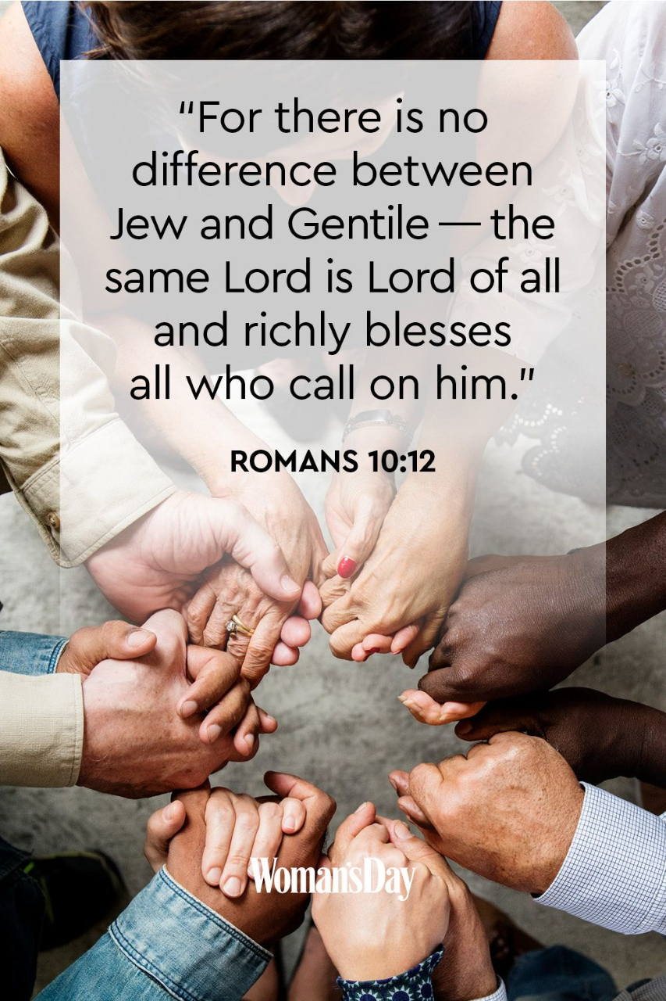

Black History Month

Miss Threlfall is our History subject leader. During whole school worship on Monday, she focused on Black History Month with the children. The children listened to 'This is Me,' from The Greatest Showman. They found out about Black History Month- when it started, how it's celebrated and why it is so important. The children discussed the meaning of racism and looked at a few examples of how people have overcome it.

What can we learn from this?

Do you have the courage to stand up for what is right?

Do you value uniqueness? How do you show this?

What does is say in the Bible?
The Bible does not start off with the creation of a special or privileged race of people. When the first human being is created he is simply called Adam, which is Hebrew for “humankind.” Adam and Eve's ethnicity is not even mentioned in the book of Genesis. Adam and Eve represent all people of all ethnicities. In Genesis 1:26 God says, “let us make man in our image, according to our likeness.” Then 1:27 describes his creative action: “So God created Adam in His own image". He created him in the image of God. He created them male and female. Christians believe that being created in “the image of God” is a spectacular blessing. It is what distinguishes people from animals. Adam and Eve represent all ethnicities.

The Bible is very clear that all people are created in the image of God, and therefore all races and ethnic groups have the same equal status and equal unique value.

Prayer
We thank you for the significance of this month.
We thank you for the opportunity to learn about Black History month.
We pray for open hearts and minds.
May this month be a time of curiosity and sharing,
Conversations and celebrations,
Challenge and encouragement.
Dear Lord, help us to dig deeper,
Look closer and think bigger.
Help us to value uniqueness.
Amen

