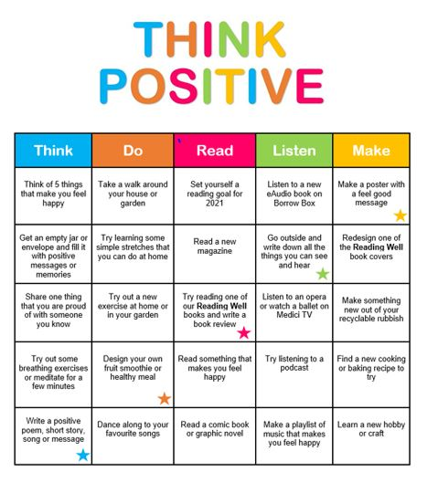

**Friday 5th February 2021**

**For English today, I would like you to have a go at these activities below and send me pictures on Seesaw on how you like to enjoy these different suggestions. Have fun!**