Wednesday 3rd February L.O. To plan a story with a stone age theme.
Story Mountain for: _____________________________________________ Name: ________________________________
Problem
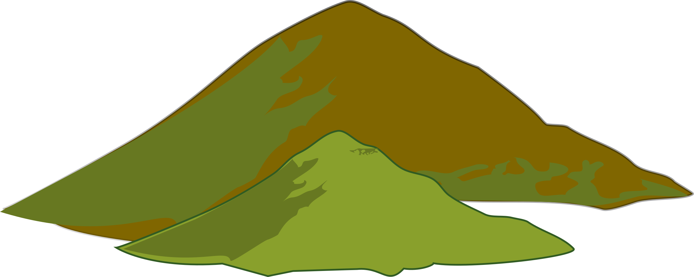
Story Mountain
Build Up
Characters

Settings

Resolution
Ending
Introduction

