L.O. To recall key events from a narrative.

Story Mountain for: _____________________________________________ Name: ________________________________

Problem

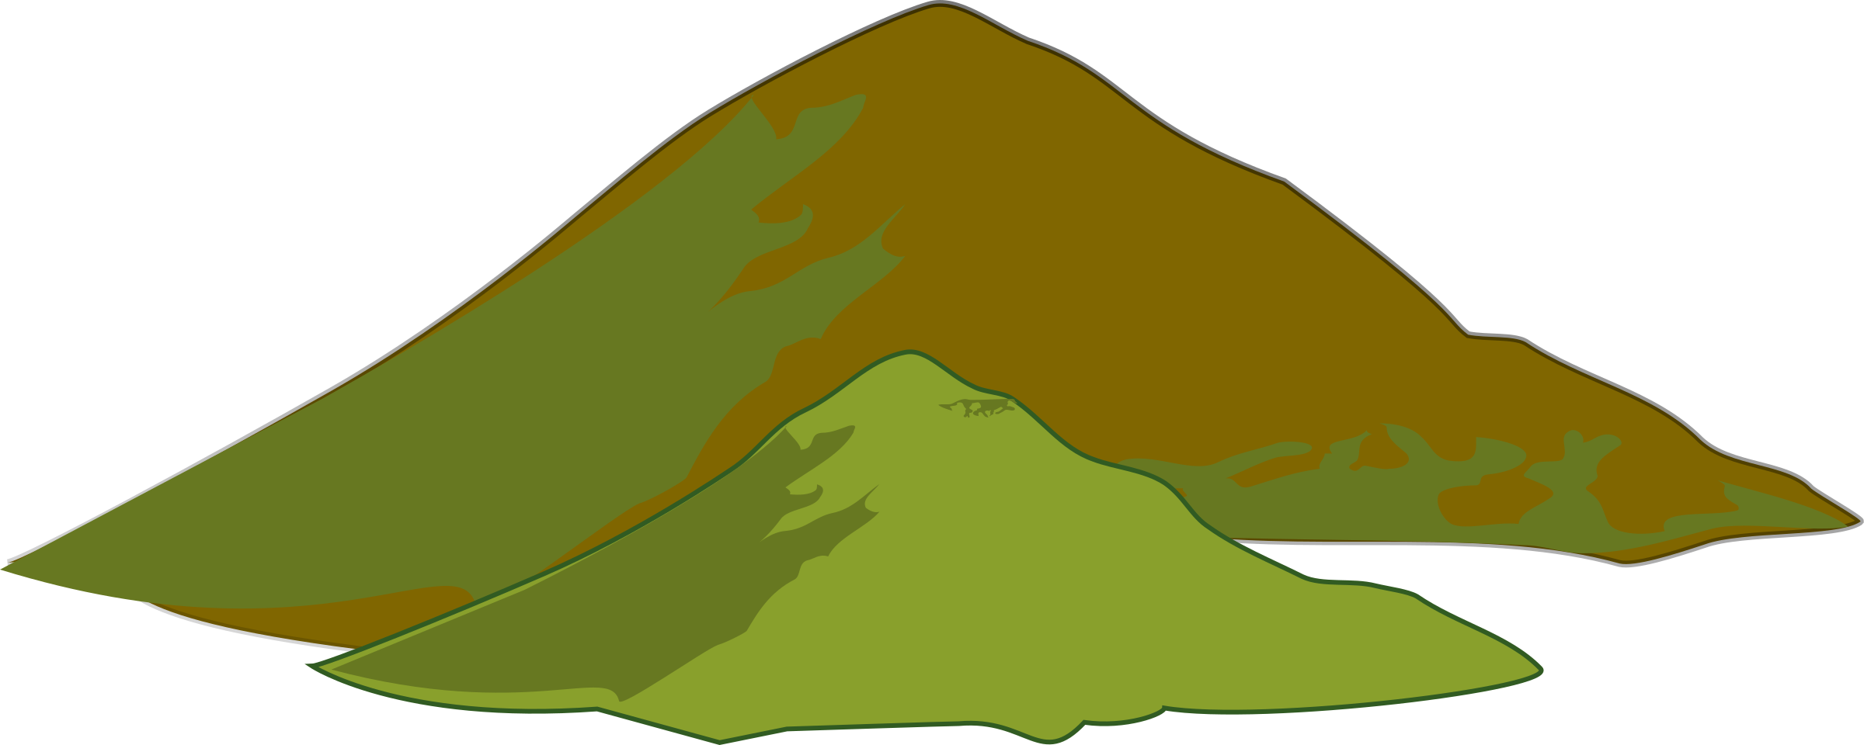

Story Mountain

Build Up

Characters

Settings

Resolution

Ending

Introduction