**Tuesday 9th February 2021- To use effective vocabulary to describe chosen pictures**

Calm atmosphere

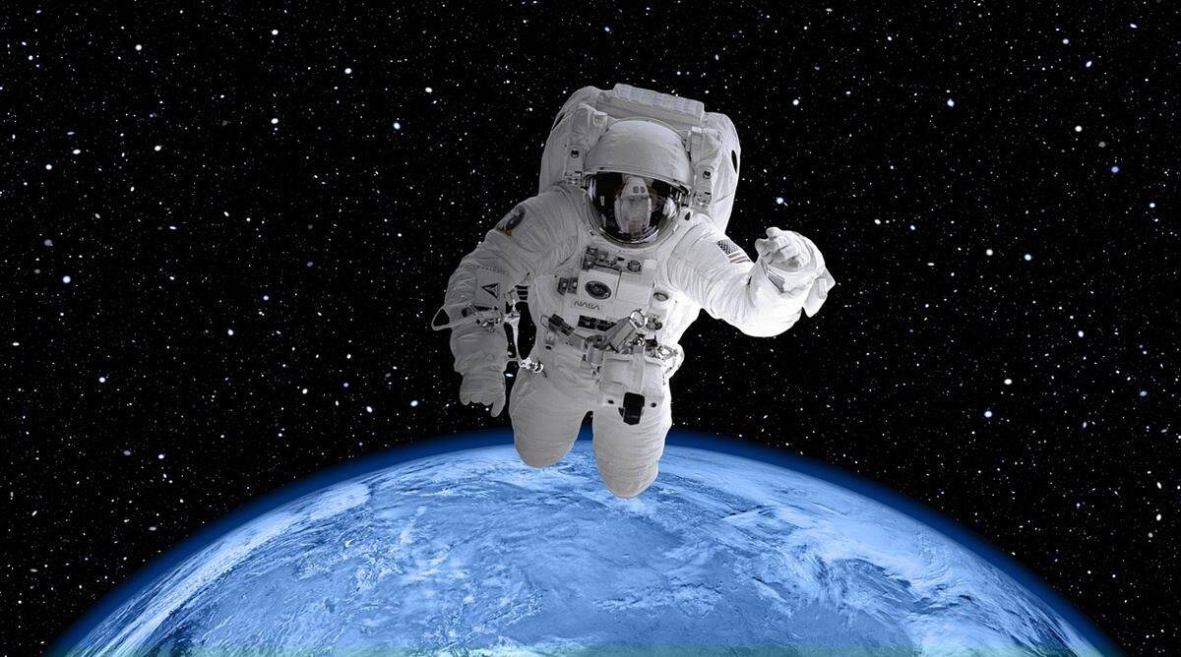

Stars making the picture

Daring astronaut looking at the breath-taking view

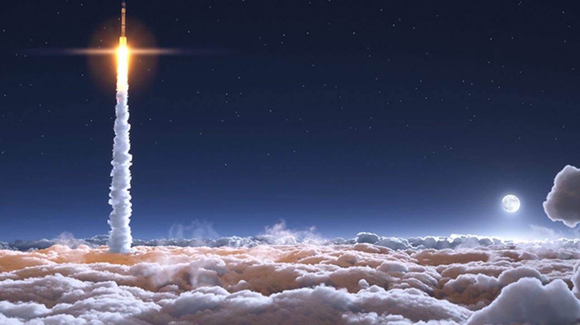

White, fluffy clouds

Glistening moon

Powerful rocket

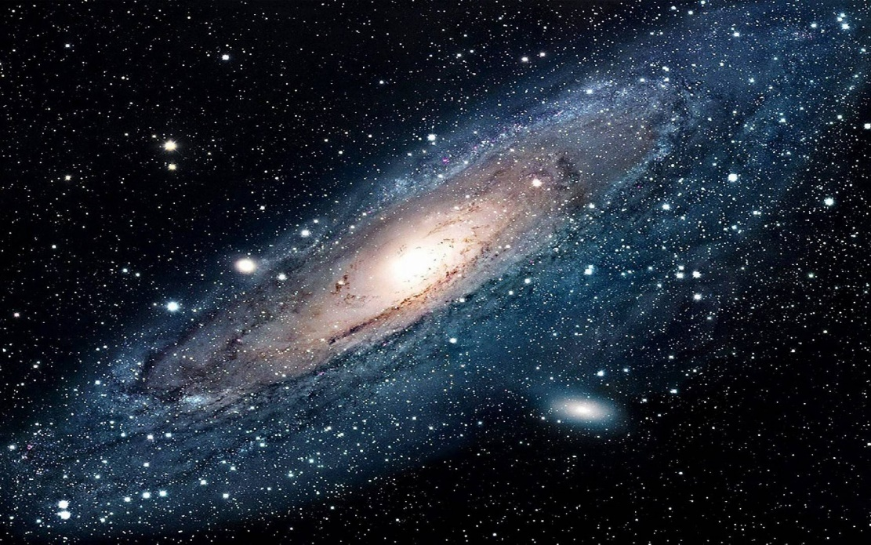

A huge collection of gases, stars and dust.

Dazzling stars

Planets being held together by gravity