**Monday 8th February 2021- To use effective vocabulary to describe chosen pictures**



Beautiful sunset

Calm, peaceful sea water washing up on the shore.

Long, green grass growing.

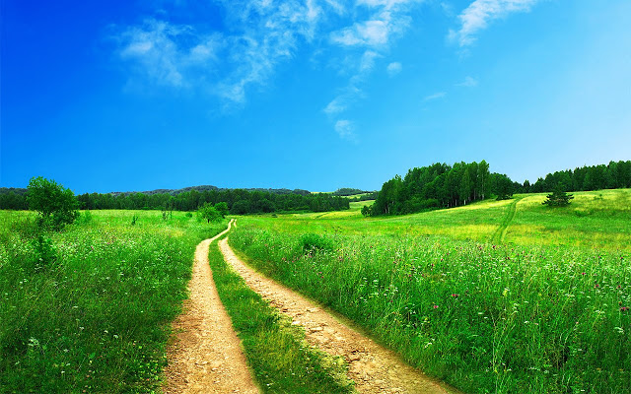

Warm, sunny day

Stunning plants starting to grow.

Leafy branches

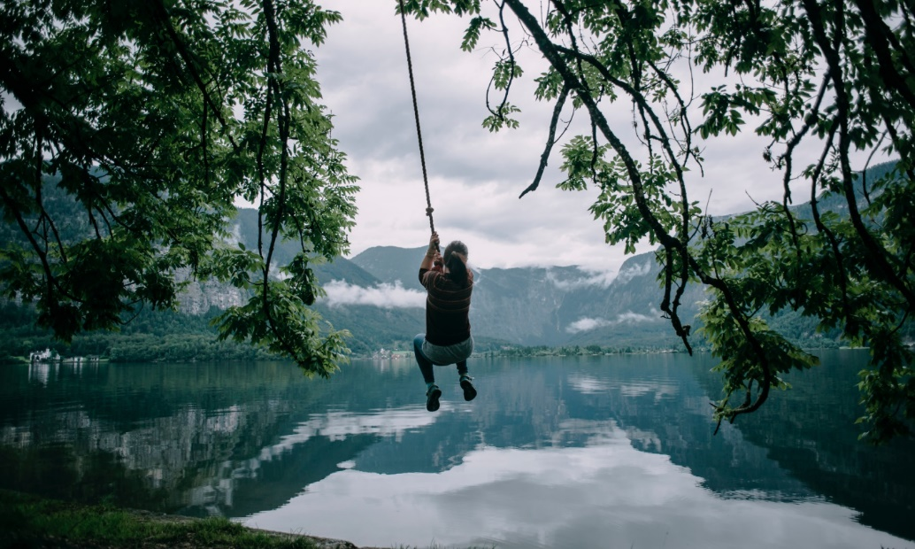

Serene water

Old, rope swing