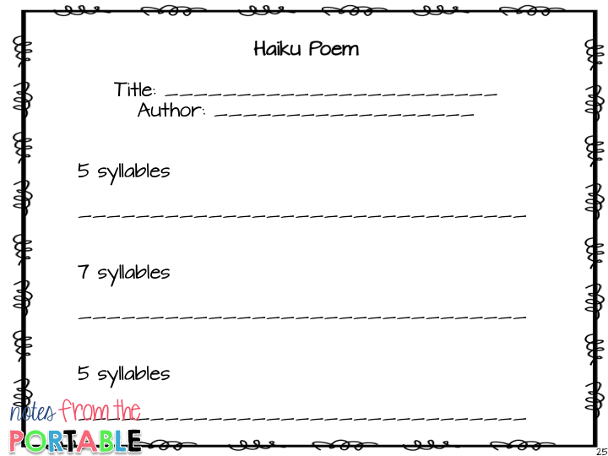

The solar system

By Miss Wheatcroft

So much to find out

Our solar system

It is so out of this world