Wednesday 24th February 2021
LO- I can say and write a simple descriptive sentence

- Fancy dress options - Get ready for a fancy dress carnival style. Follow the instructions on the slides.

- Fancy dress draw it - Draw the character in the box, use dictionaries when needed. Draw a label an extra label of your own.

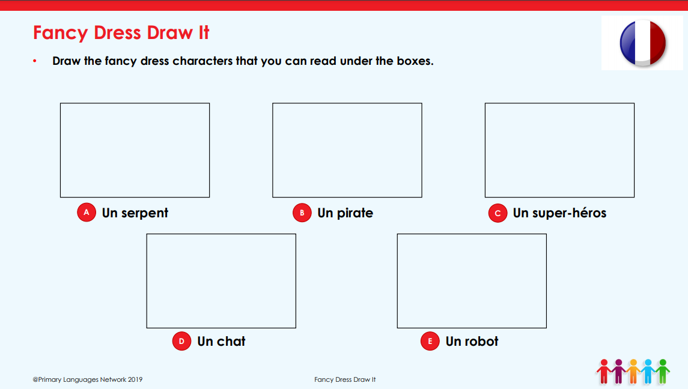
- Phonetic detectives- Spell what you hear, explore new words

