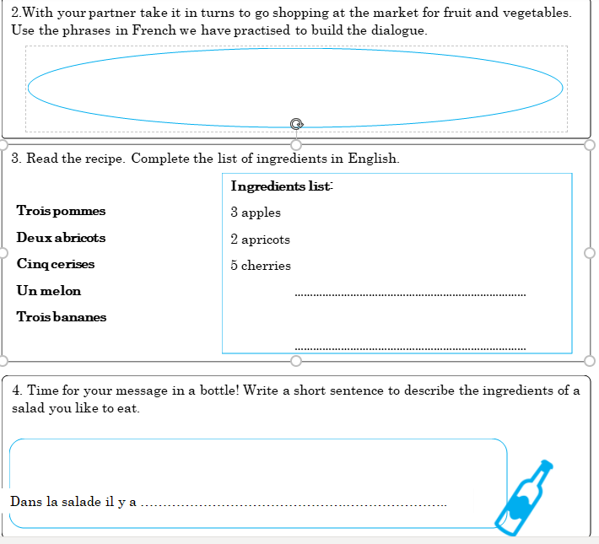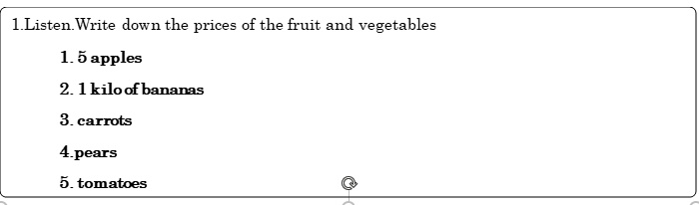

Draw your favourite fruit/vegetable

French Activity

Write down the names of these fruits/vegetables in French.