Wednesday 13th January
LO: To create settings and characters.
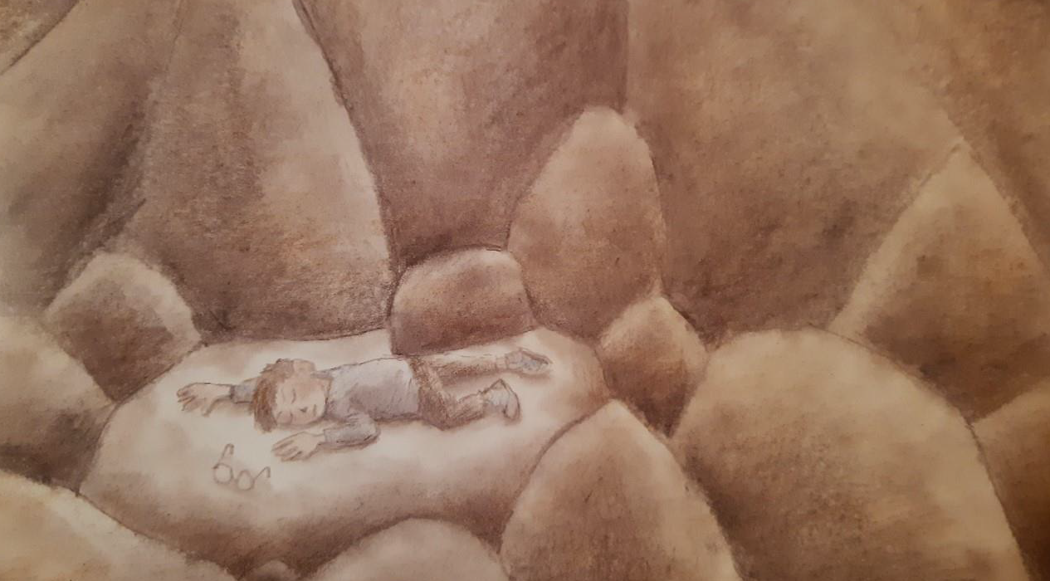
Adjectives to describe the cave (including magpied words):
___________________________________________
___________________________________________
___________________________________________

What you (writing as the boy) could feel: ____________________
___________________________________________________
What had you lost? ____________________________
How did you find them? (think about how you would have searched, without your glasses, in the dark) _________________________
___________________________________________________

How did you feel as you approached the daylight in the distance?
___________________________________________________
___________________________________________________

