English- Thursday 7th January 2021
LO- To compare a piece of text with modern day school

Starter- Discuss with a family member what you did in English on Monday.
As a group, you chose a topic and you discussed ideas of what it would look like in the future e.g. 20/30 years into the future.
The topics were food, transport, schools, homes and leisure.

Main activity- Looking at the short story on the school website, read one page at a time and identify with a family member what genre it is and give reasons for your answer. After reading the whole story, does it give you a clearer picture of what genre it is?

Using ideas in the story, form a mind map by comparing modern day school with that of the futuristic school from the text. Talk about how accurate Asimov’s prediction was (written in 1951).

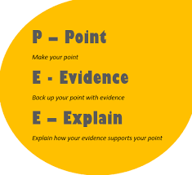
Using Point Evidence Explanation (PEE) structure. Use the whole story to form responses.

Modern day school

Futuristic school

