Beyond our solar system  Milky Way Galaxy  The sun is one of at least 100 billion stars in the milky way  Volunteers  Name 1  Name 2  •••  Contributors  Name 1  Name 2 |  | 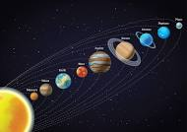
 |  | Our Solar System
 |  | • By Miss Wheatcroft

Our Plants  Mercury-  Venus-  Earth-  Mars-  Jupiter- Having 79 moons |  | What is our solar system?

