Roll a dice and put that number as “my number”. Can you work out one more and one less? Use the number line to help you.
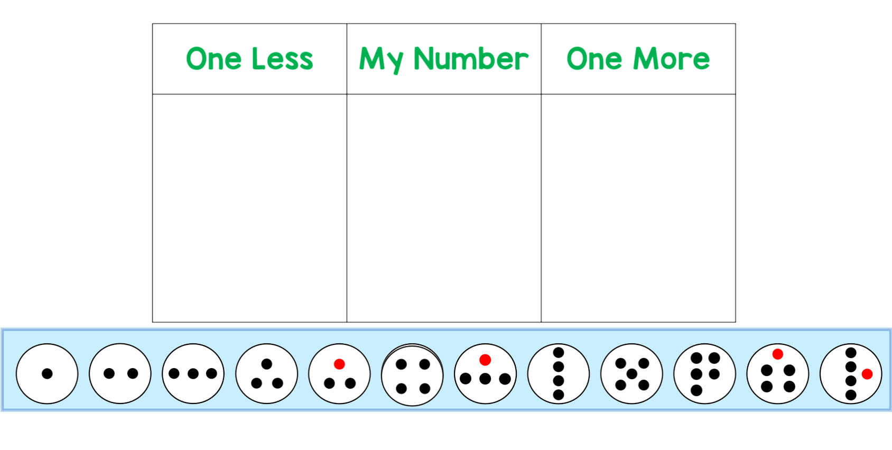
Challenge: Can you roll the dice twice and add those numbers together to make a bigger start number?

