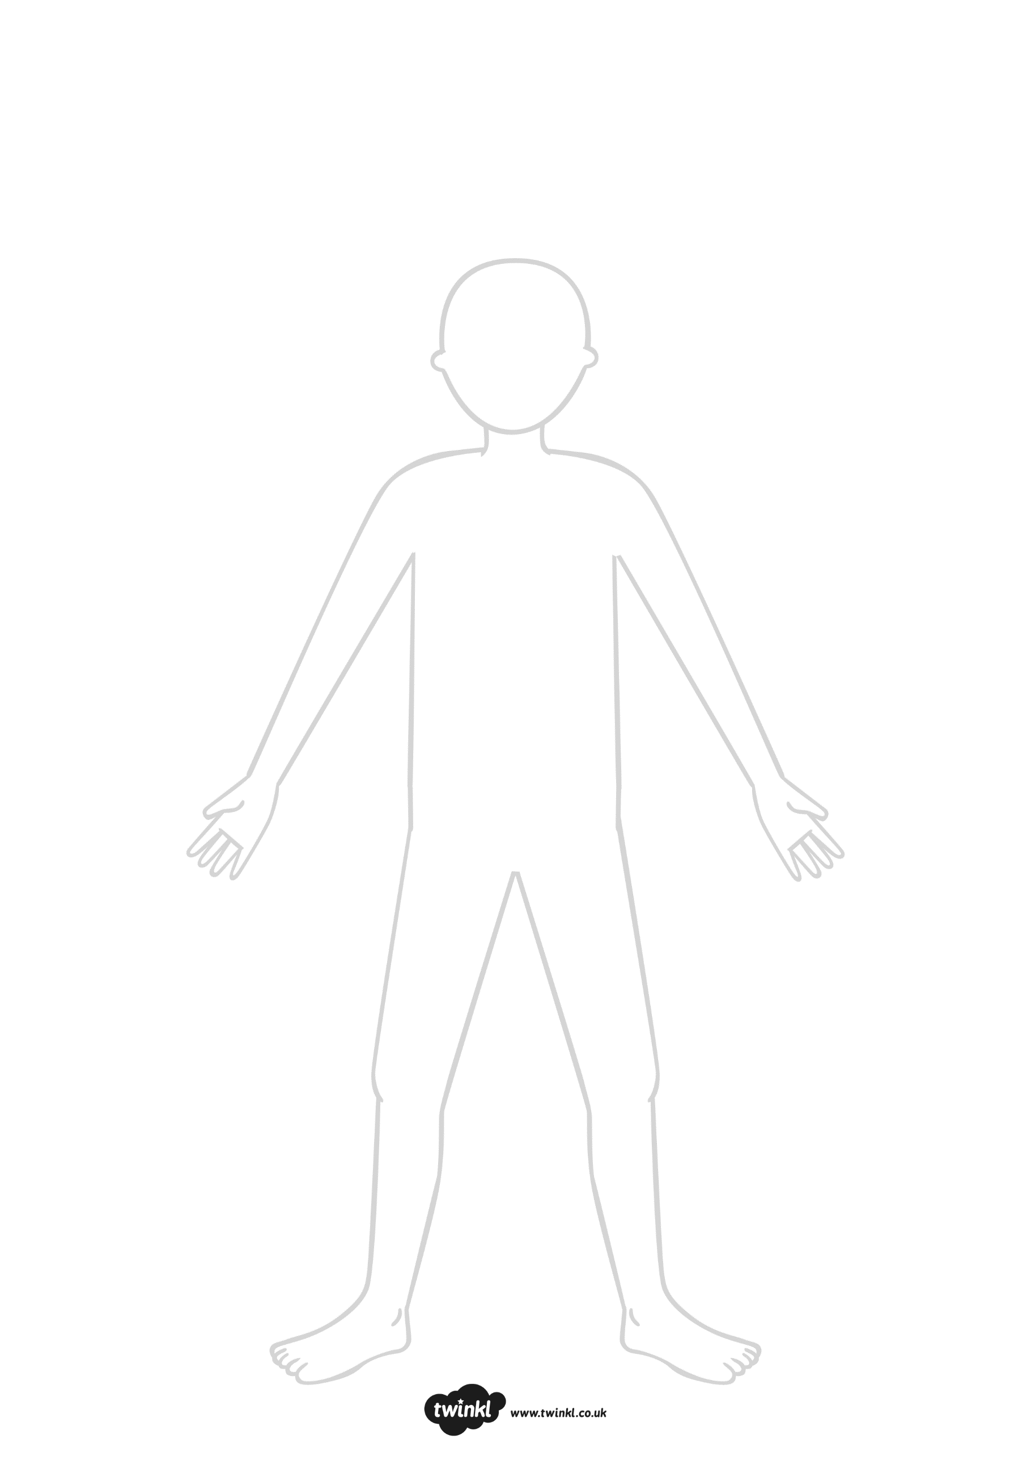

Think about how you could draw your character’s facial expressions to get their personality across.

Where and when is your story set? Could this affect what your character is wearing, or what they look like?

Try using pictures from magazines and books to inspire you.

Think of details you can use in a description (e.g. hairstyle, clothes, accessories etc.).

**Creating Characters**

Use the template to draw what your character looks like.

When answering the following questions, try to:

-use well-chosen adjectives and similes;

-reflect their personalities;

-use interesting vocabulary;

-decide on how your character might feel in different situations.

What is your character like?







Where is your character going to go? 





What is your character’s future equipment? 





**Creating Characters**

























What adventure will your character have? 





**Creating Characters**