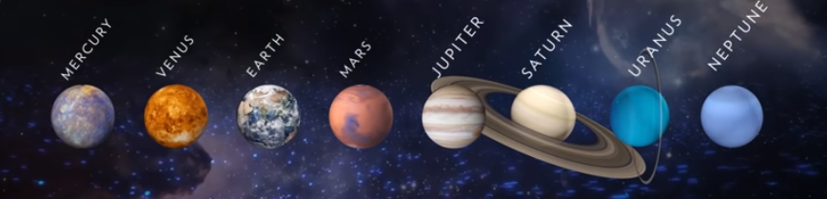
KS2 Reading Comprehension
The Solar System
https://www.youtube.com/watch?v=libKVRa01L8
- How many known solar systems are in the Milky Way?

- How many planets revolve around the sun?

- List them all.

- Terrestrial planets have rings around them. True or false?

- Earth is a Jovian planet. True or false?

- Which planet is closest to the sun?

- Explain why Venus has temperatures of up to 867 degrees Fahrenheit.

- When did Mars last support life?

- Draw lines to sort these planets into Gas Giants and Ice Giants. One has been done for you.

Jupiter
Gas Giant Neptune Ice Giant
Uranus

Saturn

- Fill in the gaps with either ‘Giant’ or ‘Ice.’

Type of Planet | Features of Planet
__________ Giants | Predominantly helium and hydrogen
__________ Giants | Contain rock, water, methane and ammonia

- “All four Jovian planets are immense in size.”

Give three synonyms for the word “immense.”
- How wide are Saturn’s signature rings?

- What is Uranus famous for?

- What is the Oort Cloud?

- Why is the Oort Cloud considered the edge of the solar system? Explain your answer.

- “Our solar system’s particular configuration of planets and other celestial objects, all revolving around a life-giving star, make it a special place to call home.”
Explain why the word “our” has been used here.

Answers
- Over 500
- 8
- Mercury, Venus, Earth, Mars, Jupiter, Saturn, Uranus, Neptune.
- False
- False
- Mercury
- It is due to an atmosphere of carbon dioxide and extensive lava flows.
- 3.7 billion years ago.
- Gas Giants: Jupiter & Saturn
Ice Giants: Uranus & Neptune
- Gas Giants
Ice Giants
- Various: huge, giant, massive
- Barely a kilometre thick or 0.62 miles
- Rotating on its side
- Vast, spherical collection of icy debris, considered the edge of the solar system
- Because that is where the gravitational and physical influences of the sun end.
- Various answers relating to our possession of the solar system and it belonging to us

