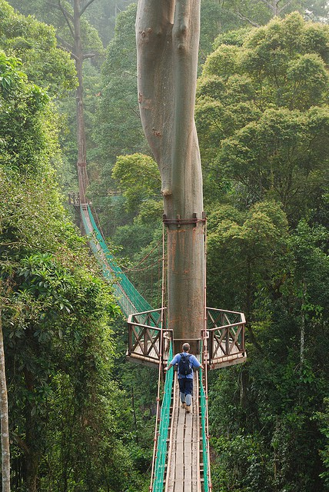
How would you feel if you were on the bridge?

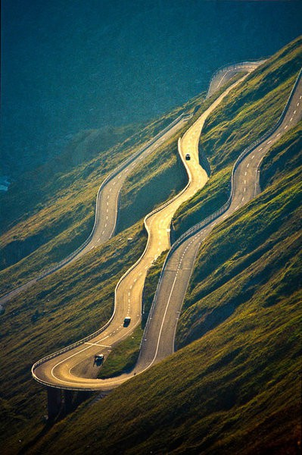
How would you feel if you were in one of the cars?
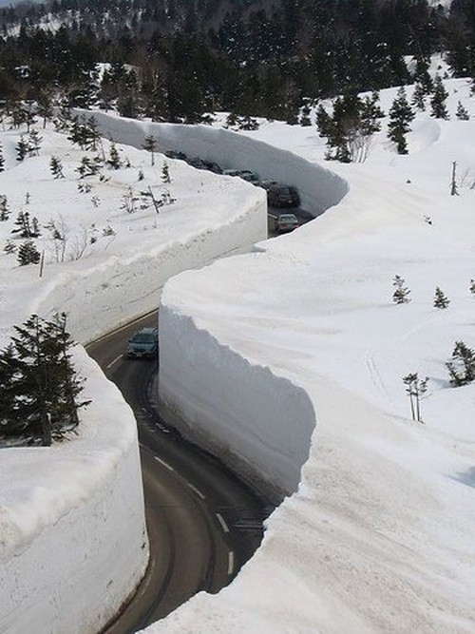
How would you feel if you were in one of the cars?

