Extension task 2.2 - Thursday

Q1 and 2

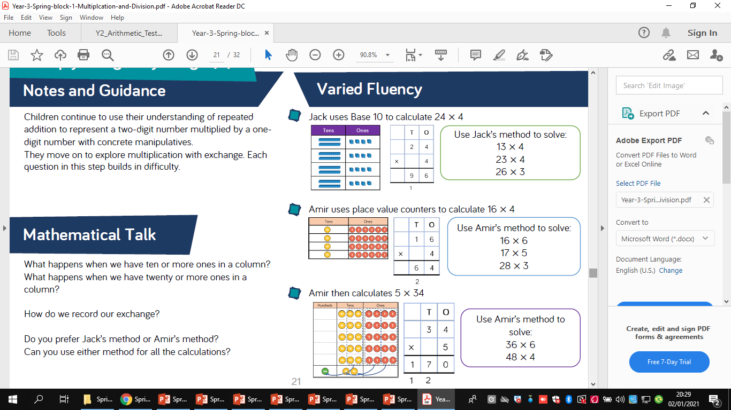

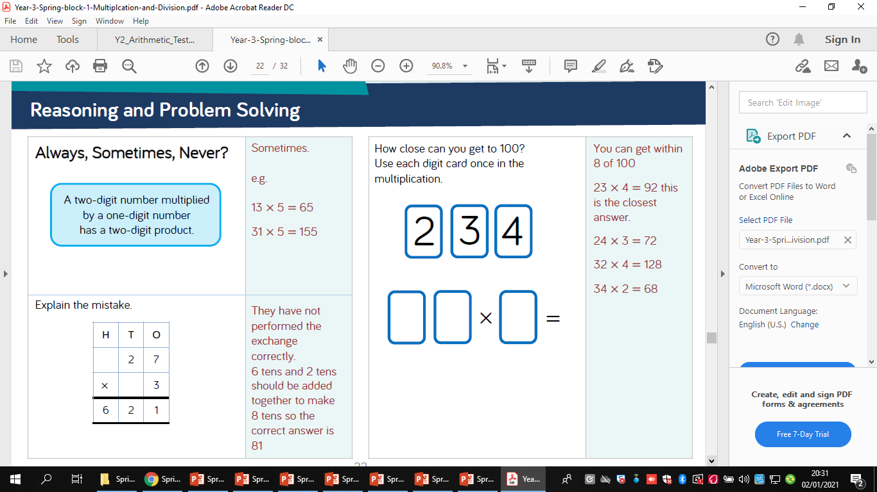

3

4.

5.