Home Learning Plan – 6th July 2020
Under the Sea

Phonics | Day 1  Review all Phase Two and Three graphemes  Read words: oh and their  Introduce the sound ‘ay’.  What words can you think of where you can hear the ay sound? Look at it as being the same as the ‘ai’ sound in Phase 3.  Read words with ay sound: day, stray, spray, crayon  Use robot arms to ask children to write:  play, say, tray and clay | Day 2  Review all Phase Two and Three graphemes  Read words: oh and their  Recap ‘ay’ sound from previous day.  Introduce the sound ‘ou’– explain that it makes the same sound as ‘ow’.  Read words with ‘ou’ sound: out, about, sprout, loudest  Segment to spell:  cloud, sound, found, proud | Day 3  Review all Phase Two and Three graphemes  Read words: oh and their  Recap: ay, ou  Letter Formation  c, f, k, l, q, r, v, x, z | Day 4  Review all Phase Two and Three graphemes  Read words: oh and their  Recap: ay, ou  Introduce the sound ‘ie’. Remind them that it is the same sound as ‘igh’ from Phase 3.  Read words: pie, tried, fried and replied.  Segment to spell:  lie, tie, cried, spied
Literacy/  Theme | Monday  Read the story ‘Rainbow Fish’. You tube link:  https://www.youtube.com/watch?v=r9mryuEKkKc&safe=active  Discuss the different characters throughout the story (e.g. Rainbow Fish, Little Blue Fish, the octopus). How are they feeling? Why? Why might Rainbow Fish not want to give away his sparkly scales?  Discuss what it means to feel ‘lonely’ and why Rainbow Fish felt lonely. What can we do to stop people feeling lonely?  Discuss being a good friend and sharing. How can we share? How can we be a good friend?  Draw pictures around a page with ideas of how we can share or be a good friend. Add labels. |  |  | Tuesday  Re-read the story of Rainbow Fish (use youtube link) – sequence the story in order. Using the resource sheet.  First, Next, Then etc. Cut pictures and put them in order.  Add a sentence underneath.

Maths | Wednesday  Talk about measuring the length of an object. Explain that we can measure using different things – rulers, cubes, hands etc.  Choose something to measure with so could be counters, pasta, smarties etc.  Children to measure using their chosen object – measure things around the house and also the sea creatures. | Thursday  Under the sea activity books – work through as example.  Consolidation activity.  Odd/Even have been looked at in lockdown so should be ok – may need some help with counters.

Theme | Rainbow Fish Collage  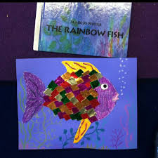 | Design, draw and colour a different rainbow animal  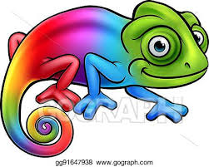 | Under the sea addition and subtraction  (use resources sheet)

