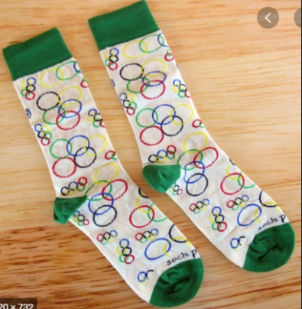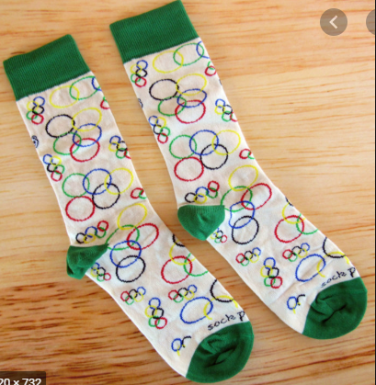

**Welcome to the**

**Grimsargh St Michael’s Y5**

**Sock Olympics!**

When you have completed the activities, **send a clear photo of your score card to Mrs Loughran via email**! We will then count up the points to find the winning Olympics team!

This year, Sports Day is looking a little different! Due to the Tokyo 2020 Olympics being postponed until 2021, We have planned a Sock Olympics just for you!

**You will need:**

A ball of socks!

Stopwatch/timer

Tape measure

Teacher demonstration videos (Mr B will post on Seesaw and our school website)

Have a go at the different activities and record your scores on the score card!

Mr B will demonstrate each activity on our school Seesaw class page and school website!

We would also love to see any photos/videos of you completing events!

‘

**Yellow Team**

**Red Team**

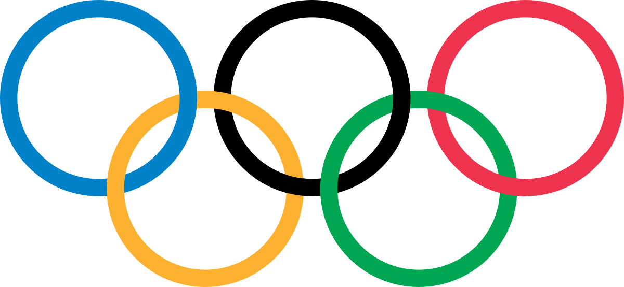

**Blue Team**

**Green Team**

**Year 5 Sock Olympics**

**Results Table!**

**Sock Throw**

Choose a starting position then see how far you can throw your ball of socks.

Measure your throw to the nearest cm!

Watch Mr B demonstrate this on our website!

**Sock Keepy Uppies**

Can you keep your ball of socks up in the air using just your feet?

How many keepy uppies can you do in 1 minute?

Watch Mr Brooks demonstrate this on our website!

**Sock Basketball**

Put a bucket or laundry basket 4m away. How many times can you throw your ball of socks into the bucket, collect, return and throw again in 1 minute?

Watch Mr Brooks demonstrate this on our website!

**Sock Catch**

Drop your ball of socks behind your head then quickly try and catch it between your legs! Have a practice first! How many can you catch in 1 minute?

Watch Mr Brooks demonstrate this on our website!

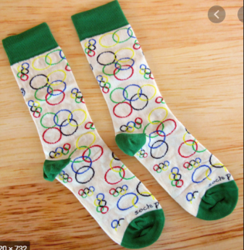

**Rainbow Sock Throw**

Put your socks into one hand & throw to your other, like a rainbow arch! How many rainbows can you throw in 1 minute?

Watch Mr Brooks demonstrate this on our website!

**Jump In Your Socks**

You can put your socks down for this one (or put them on!). Stand still and jump as far as you possibly can!

Watch Mr Brooks demonstrate this on our website!

**Sock Jump**

Place your ball of socks on the floor and see how many times you can jump over them and back in 1 minute!

Watch Mr Brooks demonstrate this on our website!

**Sock Bowling**

Set up 6 skittles (toilet roll tubes or empty bottles). Stand 3m away & use your ball of socks to knock them down! How many can you knock down in 3 separate throws?

Watch Mr B demonstrate this on our website!

**Grimsargh Y5**

**Sock Olympics Activity Card!**

**Sock Basketball**

How many can you score in 1 minute?

**Sock Catch**

How many can you do in 1 minute?

**Sock Keepy Uppies**

How many can you do in 1 minute?

**Sock Throw**

Measure to the nearest cm!



**Sock Jump**

Measure to the nearest cm!

**Grimsargh Y5**

**Sock Olympics Score Card!**

**Name: _____________ Class: ____**

**Jump In Your Socks**

Measure to the nearest cm!

**Rainbow Sock Throw**

How many can you do in 1 minute?

**Sock Bowling**

Have 3 goes!

Your score will be out of 18!