Happy Easter Year 2

Here’s the Easter story for you to share.
https://www.youtube.com/watch?v=Y3UKd6LQKng
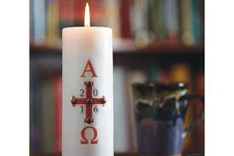
Would you like to learn more about the Paschal Candle?
The Paschal candle is a large white candle used in western Christianity. A new Paschal candle is blessed and lit each year in church at Easter, used for the whole of the Easter season and then on special occasions throughout the year.
The symbols on the candle include the light, the cross, the alpha and omega, the year and the five grains of incense.
What are the meanings of these symbols?
The flame is the risen Jesus, the light of the world. When lit the candle symbolises Jesus presence in the midst of his people.
The cross is always central.
The alpha and omega, the first and the last, what does that mean? Why is it on the candle?
The current year represents God present with his people all through the year.
The five grains of incense (usually red) represent the five wounds of Christ.

Look at pictures of several different Paschal candles. They are similar but different. Why? Which additional symbols have been used? Why?

Can you design a Paschal candle with symbols telling Jesus’ story and another with symbols telling your story.
Please take photos of your designs and send them to me via e-mail. I’d love to see photographs of your designs.

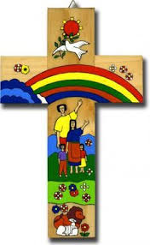

Would you like to design an Easter jigsaw?
Make a cross shaped jigsaw puzzle of the Easter Story and use it to retell the story to members of your family and friends.

I’d love to see pictures of your jigsaws and story telling.

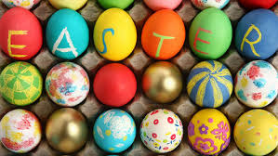
Would you like to paint a boiled egg?
Remember to take a photograph and send it to me.
Let’s see how many children in Year 2 can decorate an egg for us to display on the Year 2 website.
Remember to roll them on Easter Monday. Remember the stone that rolled away from the tomb.

Stay safe
Happy Easter
Miss Smith

