Name: Date:_______________
Homework Task Research must be completed by Monday 4th March 2019
We are going to be producing our own non-chronological reports about a country in Europe (Posters and an independent writing report). For your homework for the next two weeks, choose a European country or a region of a country and collect research about the place. You can use books, maps, the internet, tourist brochures and leaflets. You can print and bring in any information and pictures to use on for poster.
Choose at least five of the following areas to research:
- People (including children)
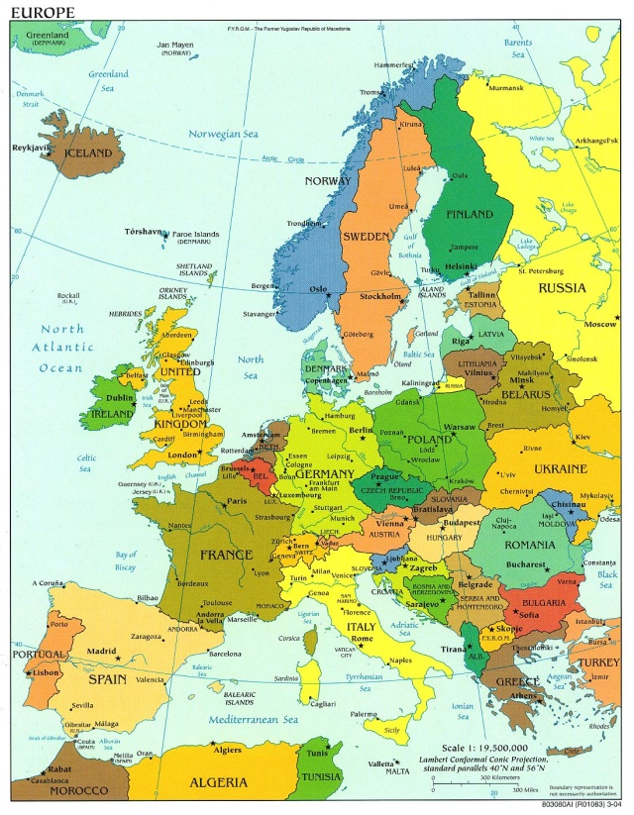
- Food
- Traditions and customs
- Tourist attractions
- Transport
- Capital city
- Towns/cities
- Weather
- Mountains/rivers
- Sports teams
- School life
- Economy and money
- Clothing

